**PRACTICAL 4**

**AIM: Data Preprocessing in Weka.**

Open file->Weka->data->weather.numeric.arff

After that click on Edit.

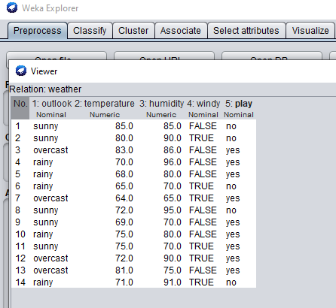

**1)NUMERICTOBINARY FUNCTION:**

Weka->filters->unsupervised->attributes->NumericToBinary

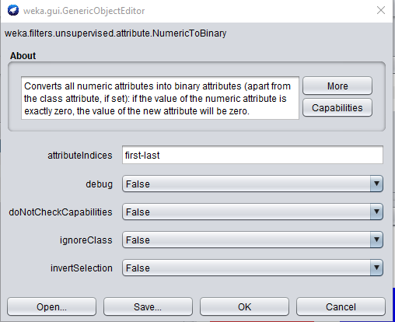

weather.numeric.arff->Edit

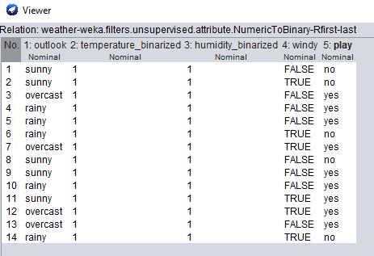

**2)OBFUSCATE FUNCTION:**

Weka->filters->unsupervised->attribute->Obfuscate

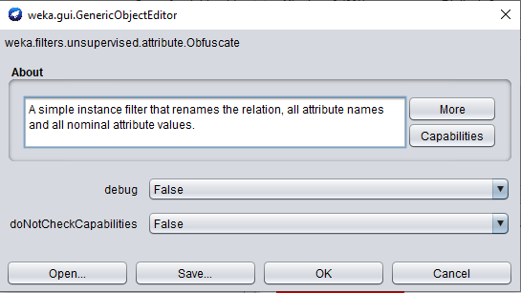

weather.numeric.arff->Edit

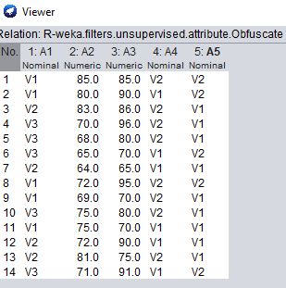

**3)NORMALIZE FUNCTION:**

Weka->filters->unsupervised->attribute->Normalize

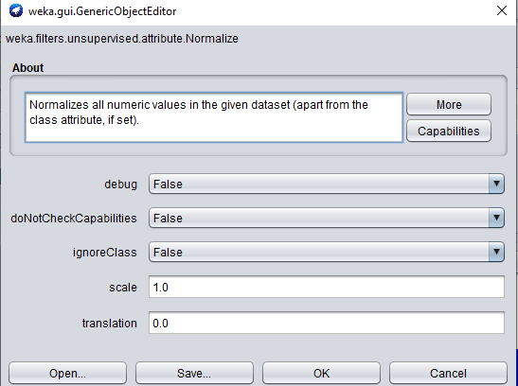

weather.numeric.arff->Edit

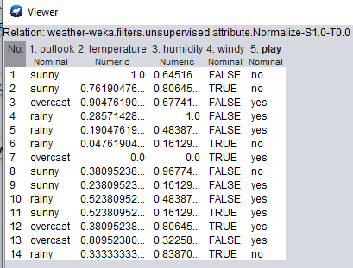

**4)ADD FUNCTION:**

Weka->filters->unsupervised->attribute->Add

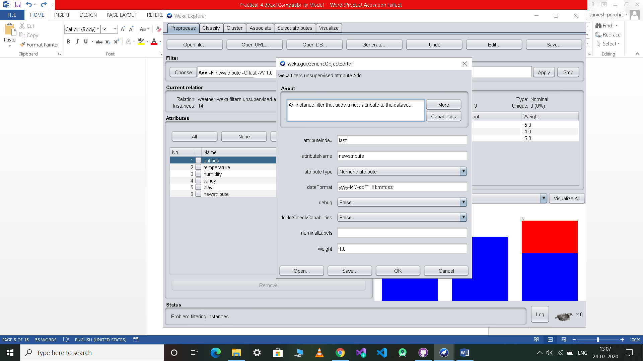

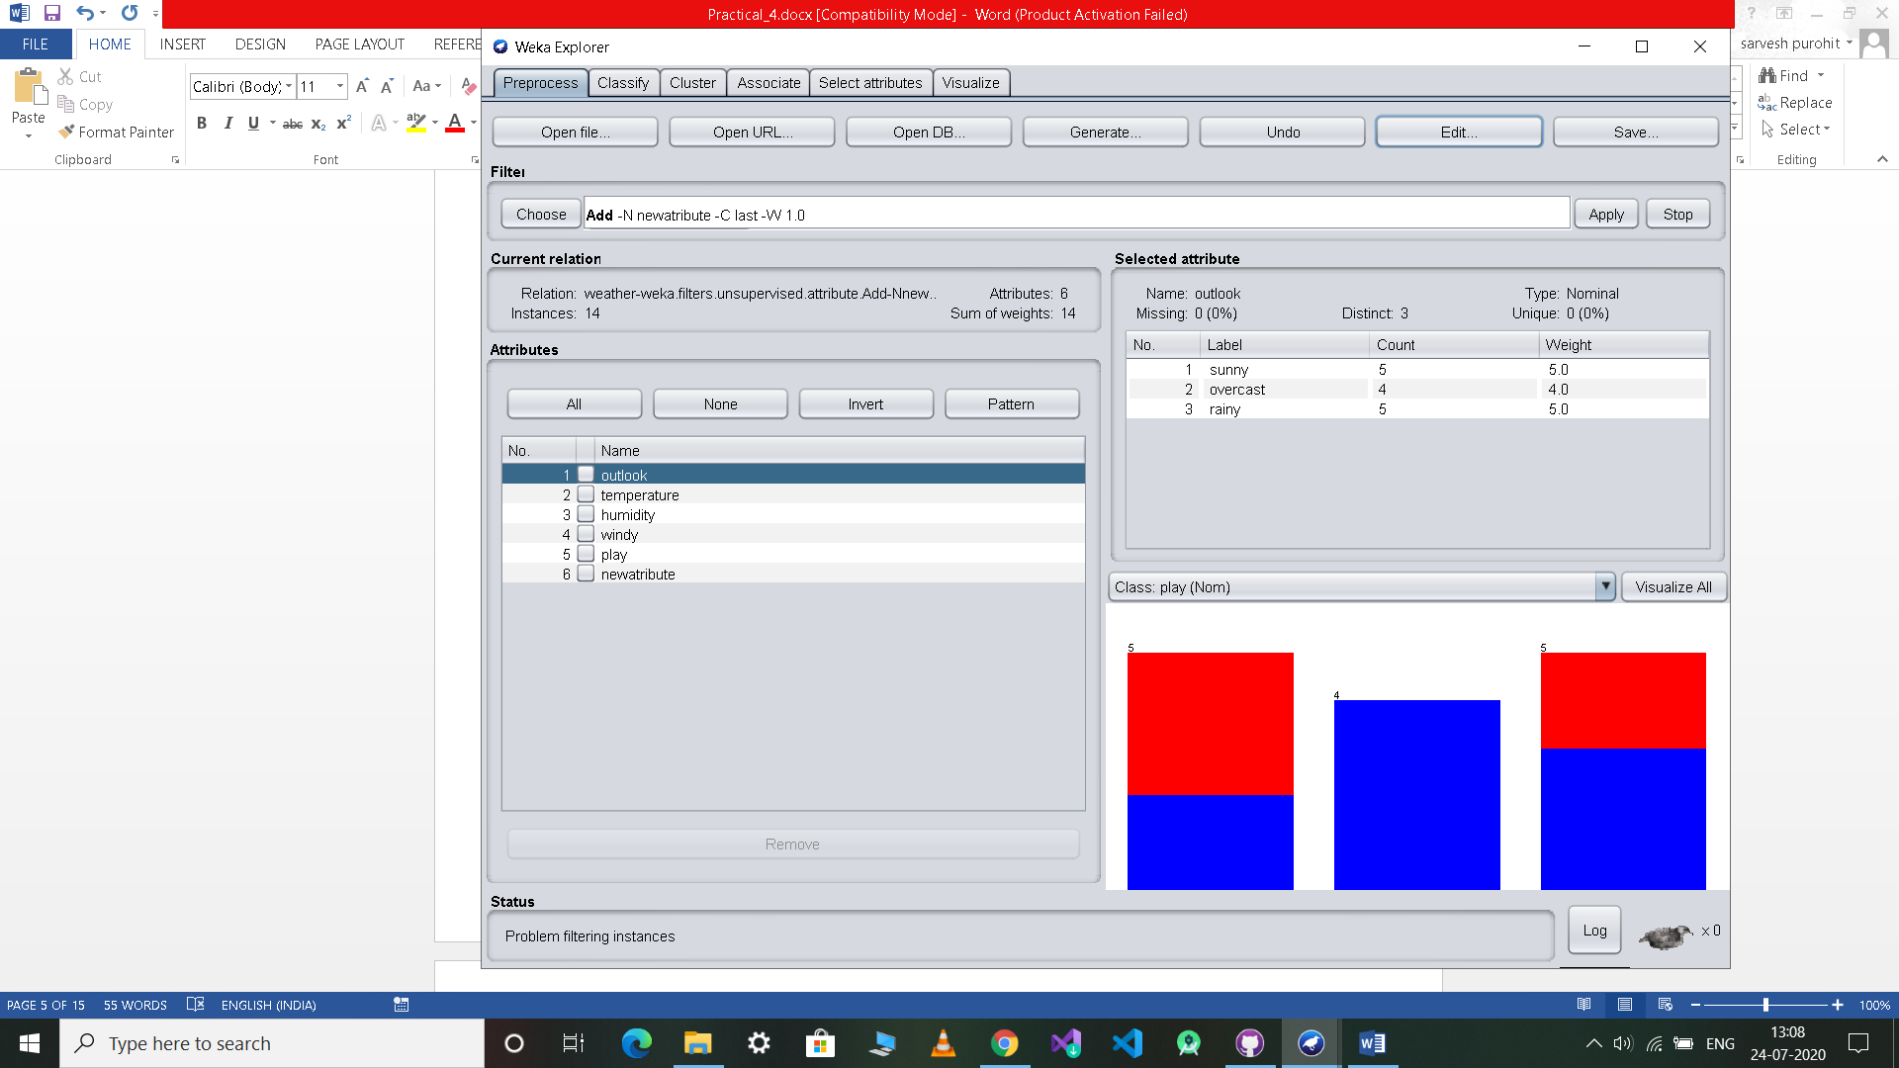

weather.numeric.arff->Edit

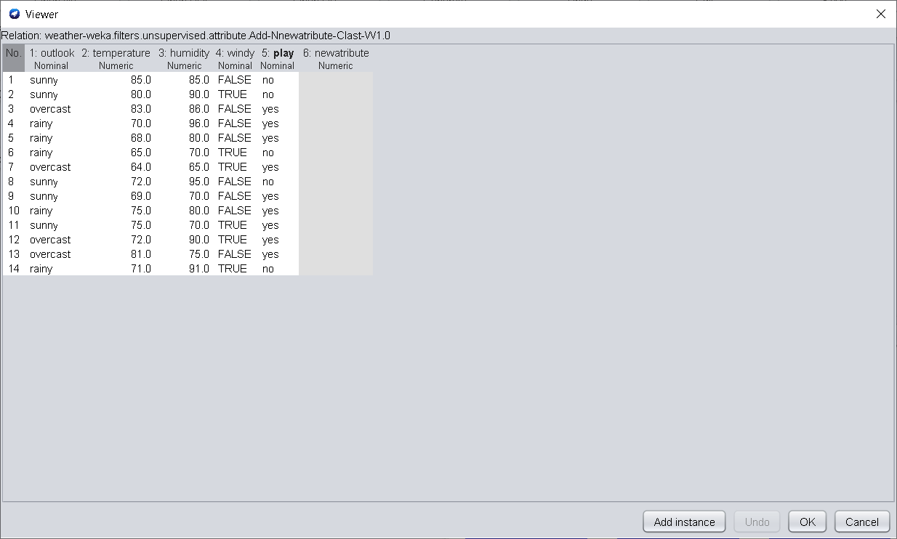

**5)REMOVE FUNCTION:**

Weka->filters->unsupervised->attribute->Remove

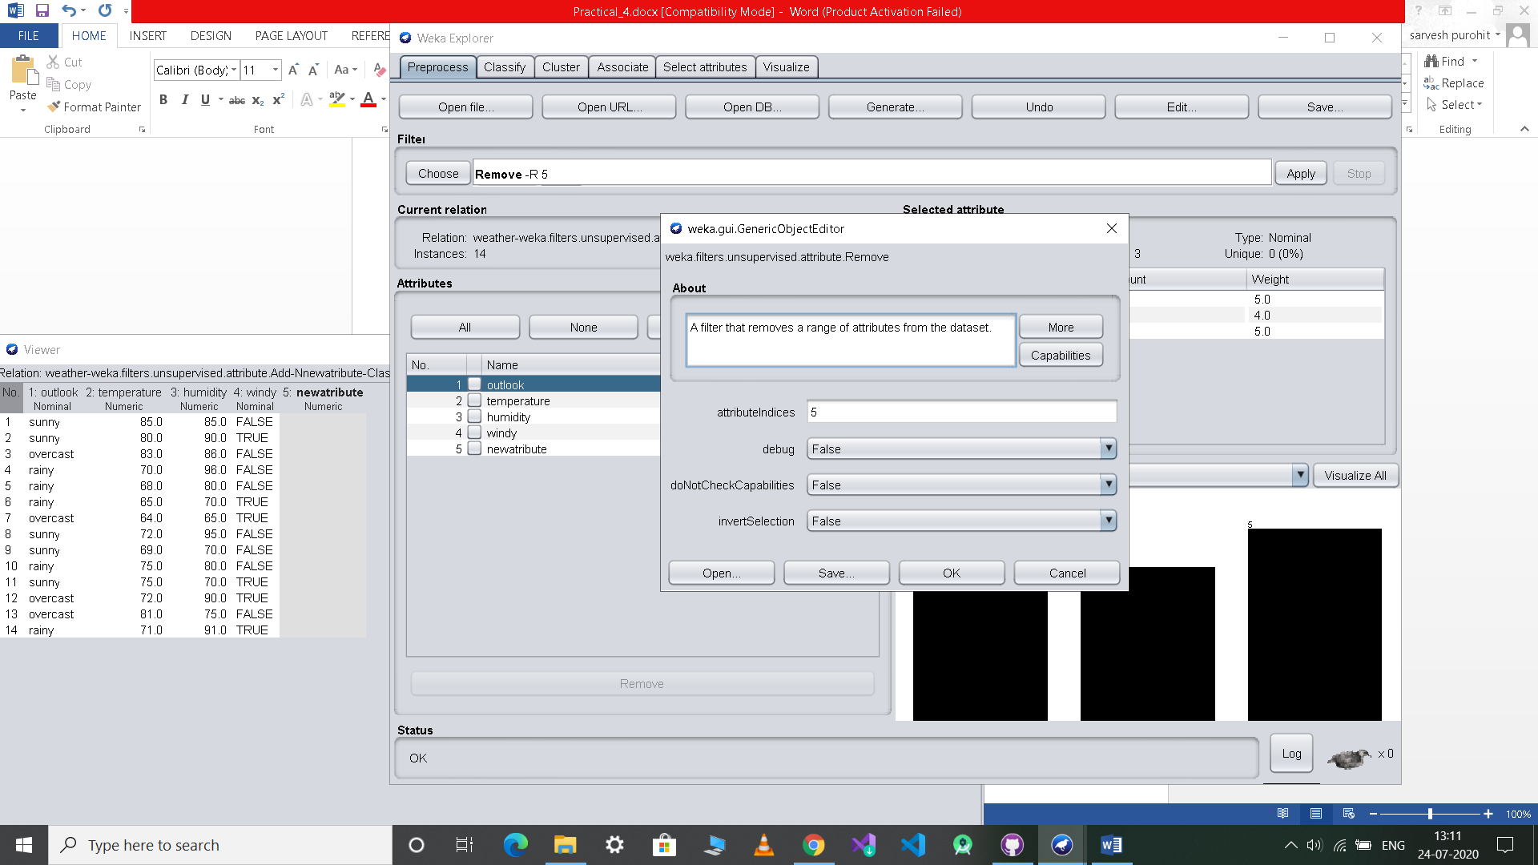

weather.numeric.arff->Edit

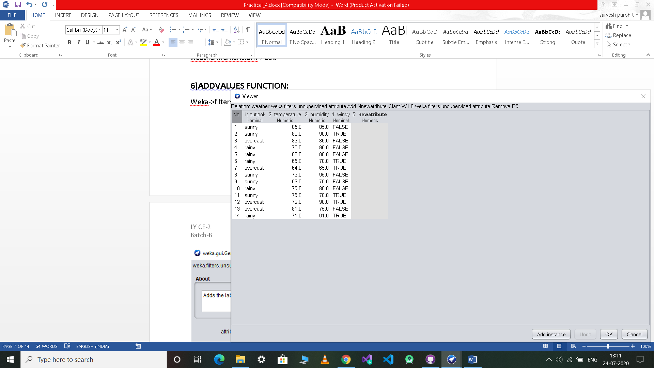

**6)ADDVALUES FUNCTION:**

Weka->filters>unsupervised->attribute->AddValues

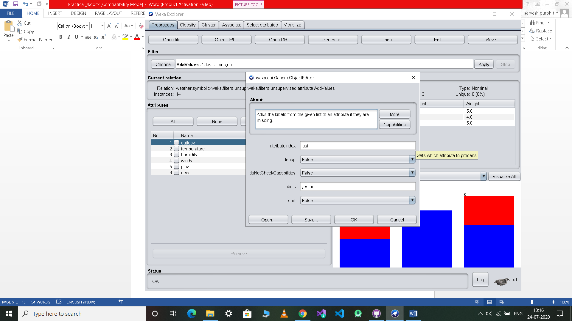

weather.numeric.arff->Edit

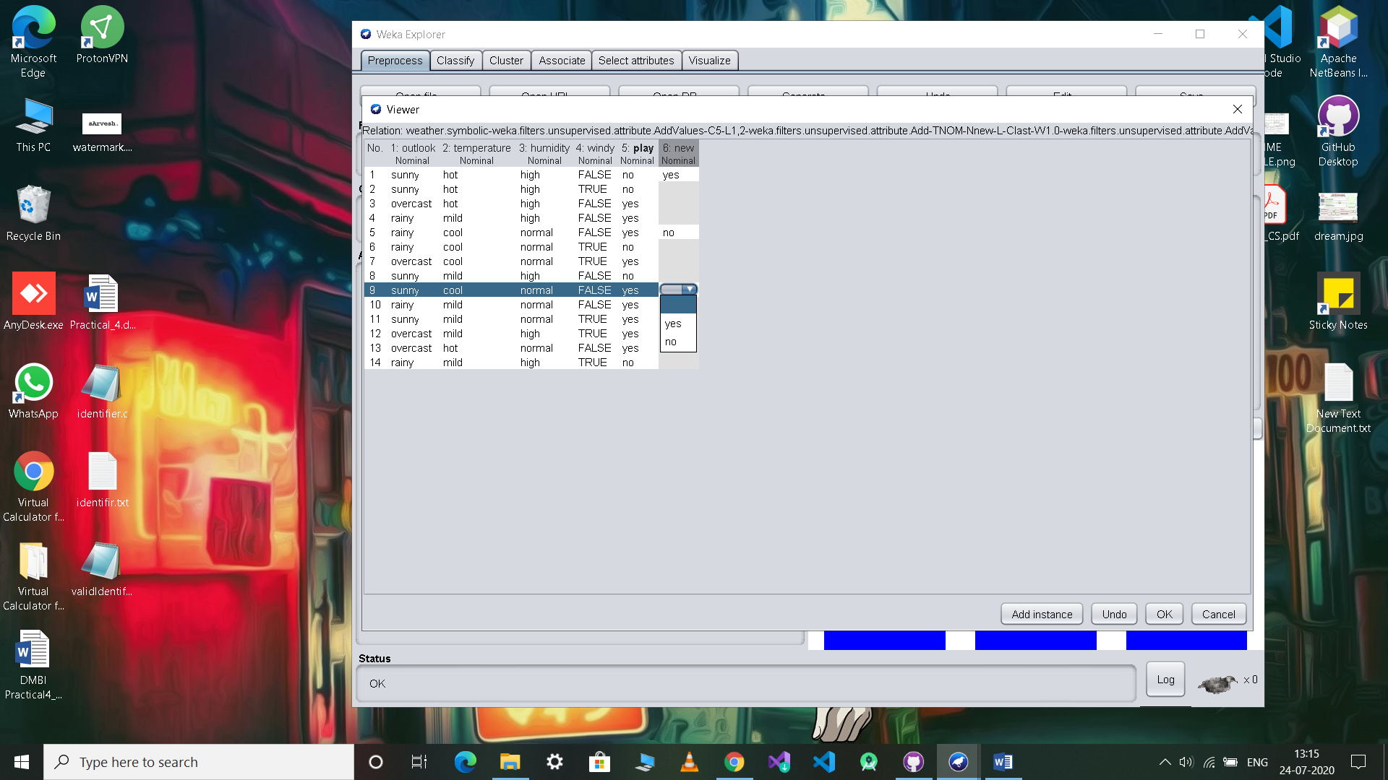

**7)ADDEXPRESSION FUNCTION:**

Weka->filters->unsupervised->attribute->AddExpression

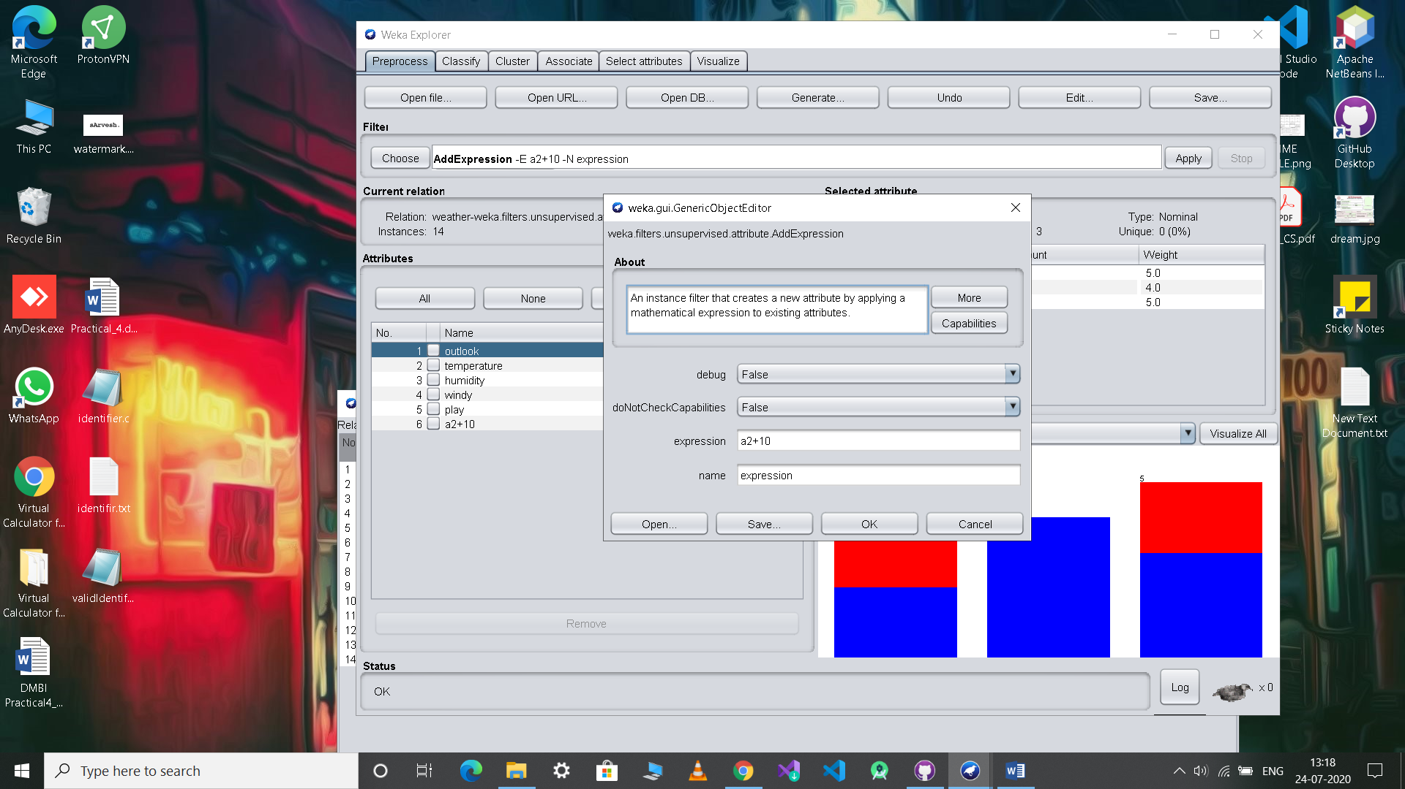

weather.numeric.arff->Edit

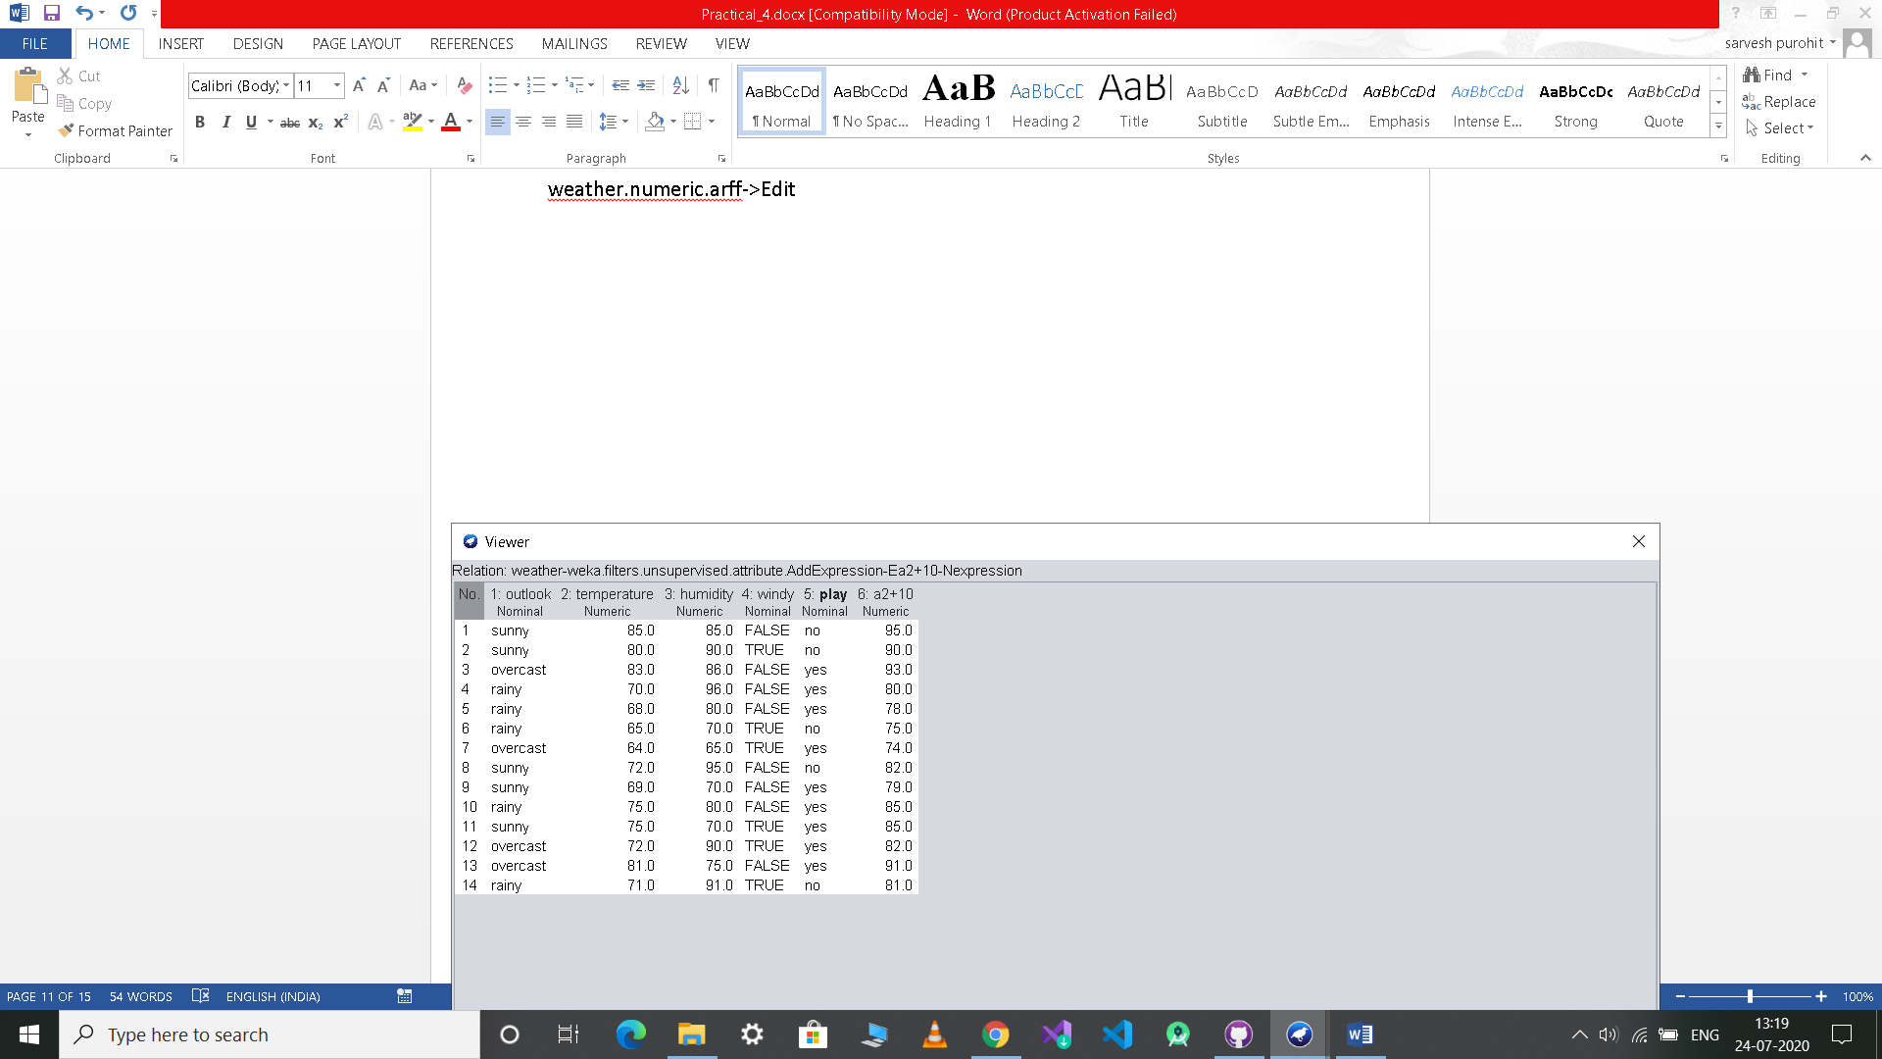

**8)MATHEXPRESSION FUNCTION:**

Weka->filters->unsupervised->attribute->MathExpression

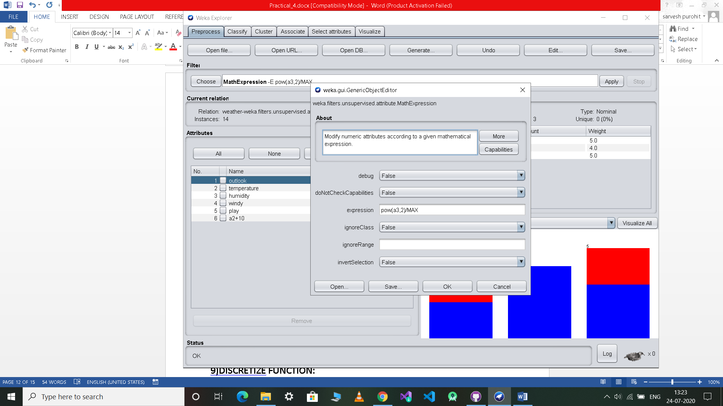

weather.numeric.arff->Edit

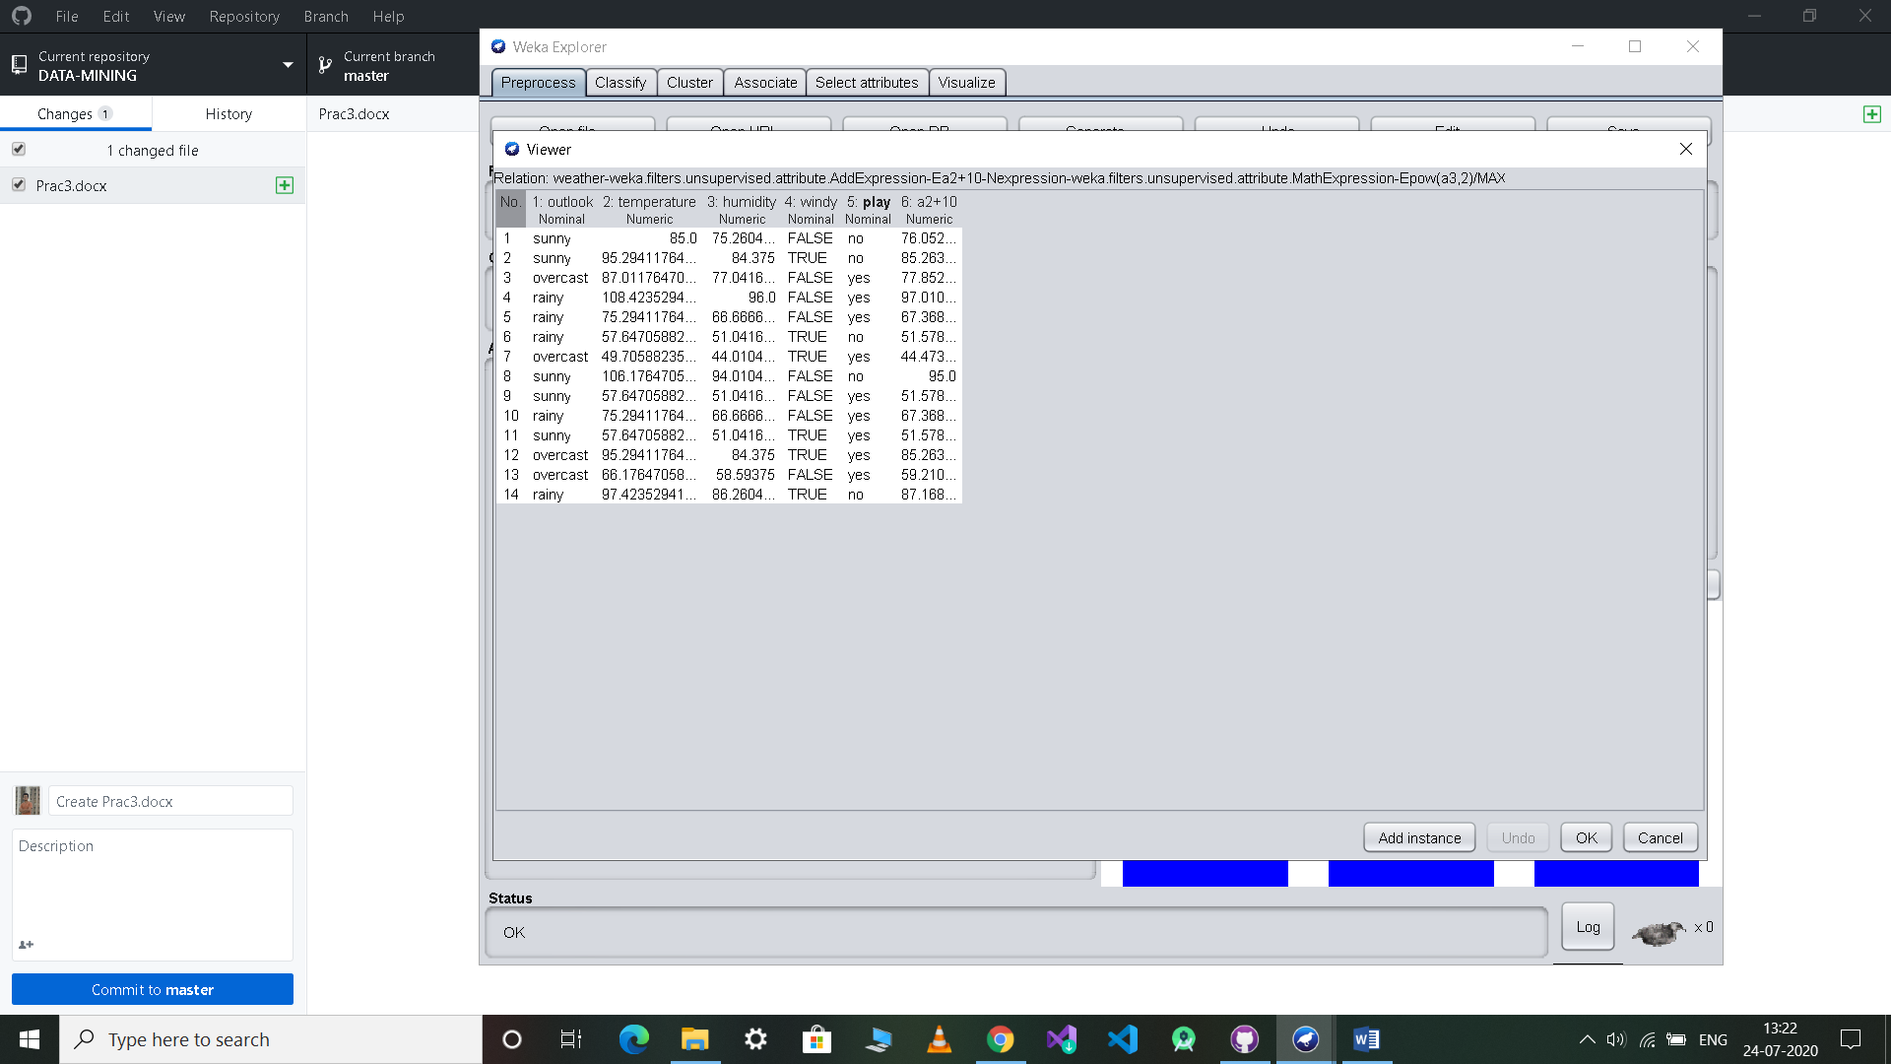

**9)DISCRETIZE FUNCTION:**

Weka->filters->unsupervised->attribute->Discretize

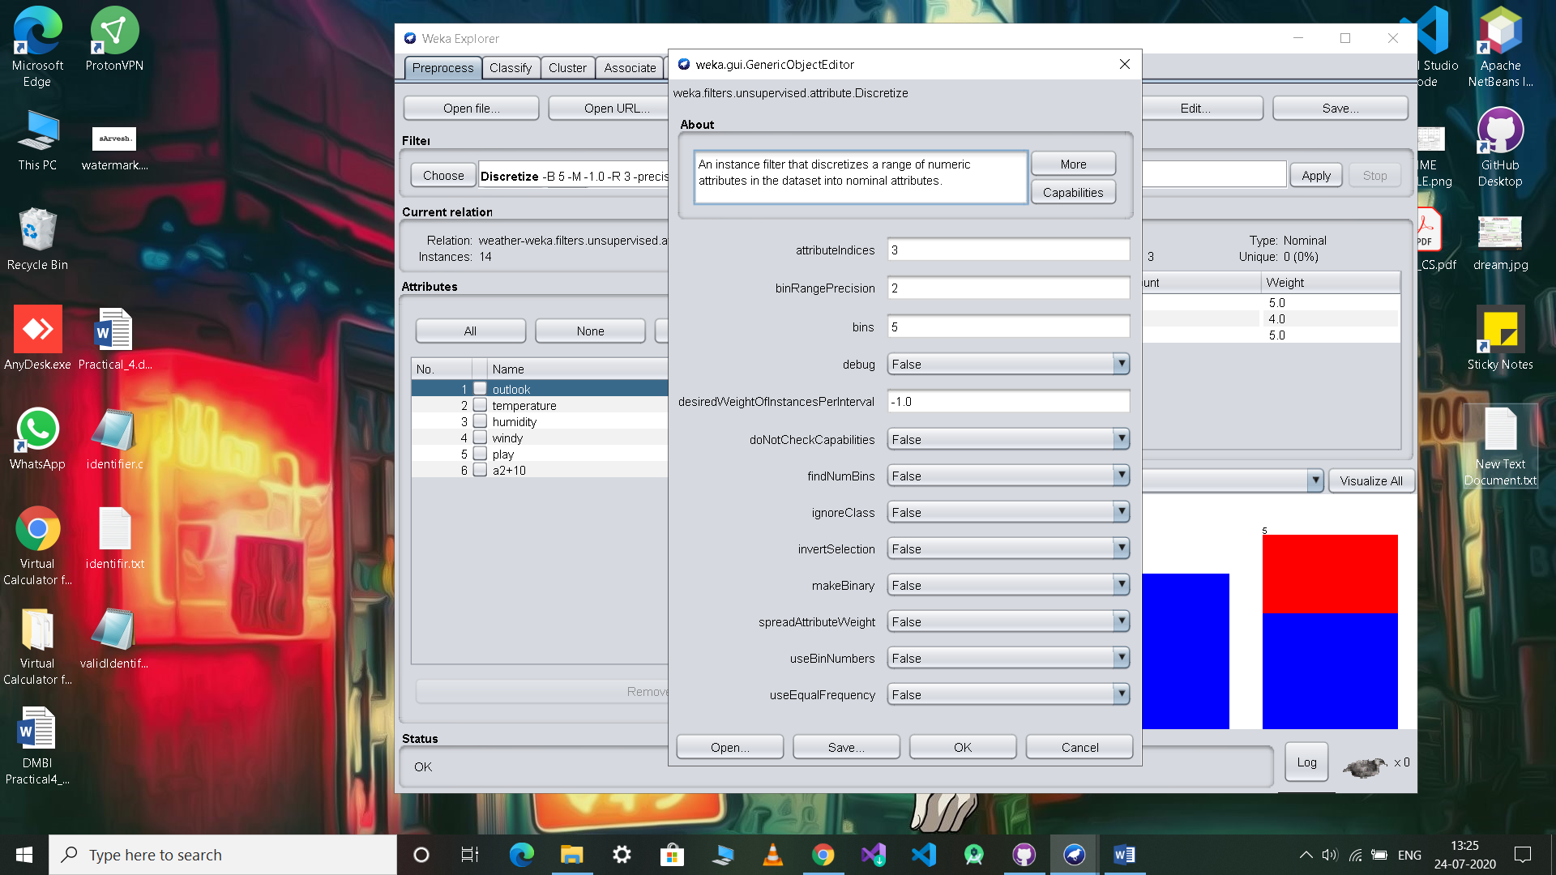

weather.numeric.arff->Edit

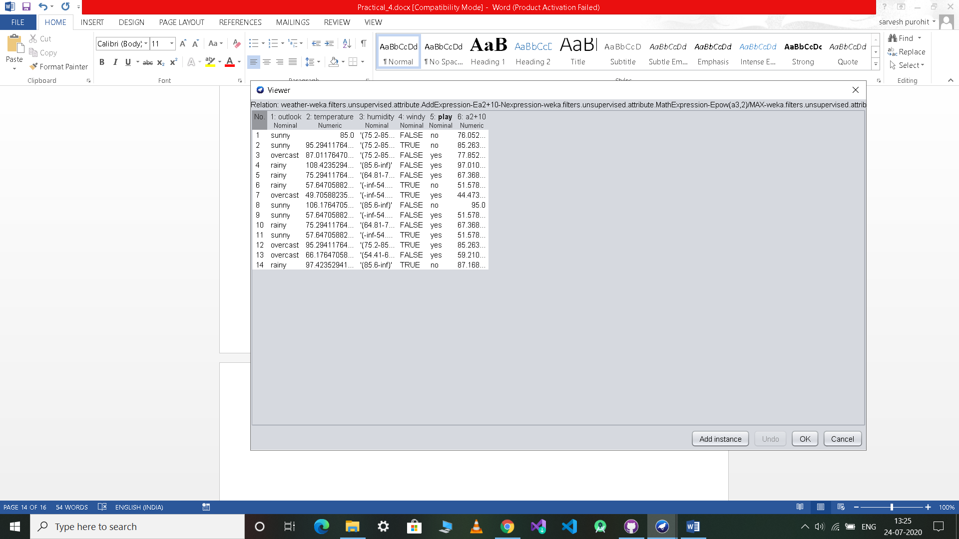

**10)RESAMPLE FUNTCION:**

Weka->filters->supervised->instance->Resample

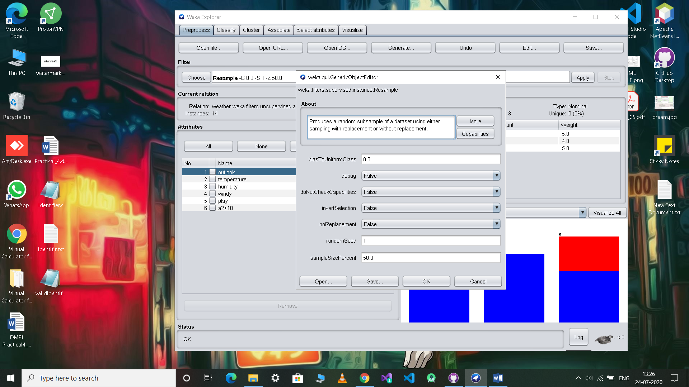

weather.numeric.arff->Edit

